Aldington, (Edward Godfree) ‘Richard’ (1892-1962)
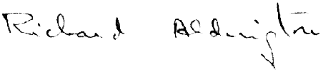
Richard Aldington was one of the original Imagist poets, along with his wife, H.D., and Ezra Pound. He was also an industrious editor of little magazines in pre-war London, and a respected critic of French literature in the post-war decade. He was profoundly affected by his experiences in the Great War, which he struggled to process, and his war novel Death of a Hero (1929) is a biting, strident criticism of the British Victorian values which he believed led to the conflict and hindered its resolution. Aldington continued to write novels throughout the nineteen thirties, and later achieved success as a biographer. His Lawrence of Arabia: A Biographical Enquiry (1955), which questioned the veracity of T.E. Lawrence’s claims to heroism – and those made on his behalf – was attacked by conservative critics, and damaged his reputation and saleability irreparably. Aldington died in central France in 1962.

Career Timeline

1912 1915 1929 1962
Imagism named First individual Publication of Dies in
by Pound volume, Images Death of a Hero France
| | | | | | |
1913 1916-19 1955
Marries H.D. Service in Publication of
Great War Lawrence of Arabia:
A Biographical Enquiry

Richard Aldington was born on the south coast of England and spent his early life in Hampshire and Kent; his parents, Albert Edward and Jessie May Aldington, both published middlebrow fiction. His education at University College London was curtailed in 1911 after one year due to a decline in his father’s finances. Determined not to resort to office work, he supported himself as a journalist for hire until he started to make his way in literary circles as a poet, reviewer and editor.

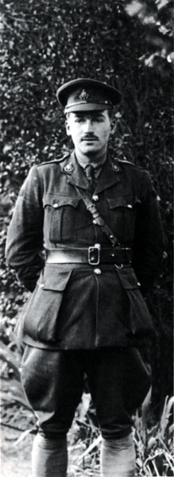
Poetry was Aldington’s passion, particularly in the early part of his career, and he was one of the original Imagist poets along with his wife, H.D., whom he met in 1911 and married in 1913, and Ezra Pound. Aldington’s early poetry is classical in subject, but develops along with the modernisms of the time into an engagement with the modernist city and its crowd. This shift is seen clearly in the poems of Images (1915). By this time Aldington was literary editor of The Egoist, a key position at this influential journal; he was succeeded by T.S. Eliot in 1918. Aldington was a champion of the modern, and consistently rejected a perceived Victorian ideal of Britishness in favour of a more cosmopolitan literary tradition and history of the world, particularly favouring the Greek and French.

Aldington enlisted in the British army just before conscription came into force in June 1916. He had been informed that he would likely be rejected for military service whilst queuing to enlist at the beginning of the war. He achieved the rank of acting captain by his demobilization in February 1919. Aldington was affected psychologically by the war, and physically by the gas bombardments he endured. He struggled to readjust to civilian life, and his marriage with H.D. essentially ended with the war (although they did not divorce until 1938); his Images of War and Images of Desire (both 1919) express war’s impact on him. He distanced himself from London geographically, and recuperated in rural Berkshire. Aldington found creative work difficult, but built a good reputation as a reviewer of French literature for the Times Literary Supplement and also as a translator.

Aldington left England for the south of France in 1928, as he was writing Death of a Hero (1929), his trenchant critique of the Great War which combines elements of memoir, satire, social commentary and elegy. The novel was a bestseller, perhaps helped by the furore caused by its expurgation (the first unexpurgated version was published in 1965); it was among the first to capitalise on the successes of Erich Maria Remarque’s Im Westen Nichts Neues (serialised 1928, translated into English 1929) and R.C. Sherriff’s Journey’s End (first performed 1928). Aldington subsequently focused on writing fiction, and published two volumes of short stories and six further novels in the following decade.

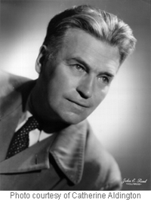
During the Second World War Aldington moved to Florida and then California, spending some time as a screenwriter in Hollywood; he published his witty, engaging memoir Life for Life’s Sake in 1941. He returned to France after the war, and his focus was on biography after his prizewinning Wellington (1943). The controversial Lawrence of Arabia: A Biographical Enquiry (1955) was attacked by defenders of T.E. Lawrence for its revelations about his bastardy and implications of homosexuality, and Aldington was vilified in the press. He struggled subsequently to sell books to live, as he had done successfully throughout his career, and died in straitened circumstances in Sury-en-Vaux, France, in 1962 only a year after H.D., with whom he rebuilt a strong relationship through correspondence in later years.

Biographical sources
Doyle, Charles (1989). Richard Aldington: A Biography. Basingstoke: Macmillan.
Gates, Norman T. (1992). Richard Aldington: An Autobiography in Letters. University Park: Pennsylvania State University Press.
Zilboorg, Caroline (ed.) (2003). Richard Aldington & H.D.: Their Lives in Letters, 1918-61. Manchester: Manchester University Press.

Selected Works by Aldington
Images 1910 -1915 (1915)
Images of War (1919)
Images of Desire (1919)
Death of a Hero (expurgated edition 1929; unexpurgated edition 1965)
All Men Are Enemies (1933)
Life for Life’s Sake (1941)
Wellington (1943)
Richard Aldington: Collected Poems (1948)
Lawrence of Arabia: A Biographical Enquiry (1955)

